Time Trial Event supported by:

Open Time Trial – 20th June 2021
On course U47/R (10 miles)
Promoted for and on behalf of Cycling Time Trials under their Rules and Regulations
Timekeepers: Sue Andrews and Andrew Greatwood
Event Secretary: David Wright, 24 Matthews Walk, Cirencester, GL7 1HL
Tel: 07715652408, Email: dnwright1963@gmail.com
Emergency contact on the day: David Wright 0771652408
COVID-19 PRECAUTIONS: This event will be conducted in accordance with the CTT risk assessment for Covid-19 (details can be found on https://cyclingtimetrials.org.uk/documents/index/covid-19).

Prizes
(Female prizes kindly donated by Independent Bikeworks, Cirencester)
1st Female £30 1st Male £30
2nd Female £20 2nd Male £20
3rd Female £10 3rd Male £10
1st VET Female 50-54 £10 1st VET Male 50-54 £10
1st VET Female 55-59 £10 1st VET Male 55-59 £10
1st VET Female 60-64 £10 1st VET Male 60-64 £10
1st VET Female 65-69 £10 1st VET Male 65-69 £10
1st VET Female 70-79 £10 1st VET Male 70-79 £10
1st VET Female 80-90 £10 1st VET Male 80-90 £10

# please note only one prize per competitor

Course
The entry and exit points to the A419 will be marked with double arrows (black on white background) and the turn roundabout will be marshalled, but please be aware that it is a riders responsibility to know the course.
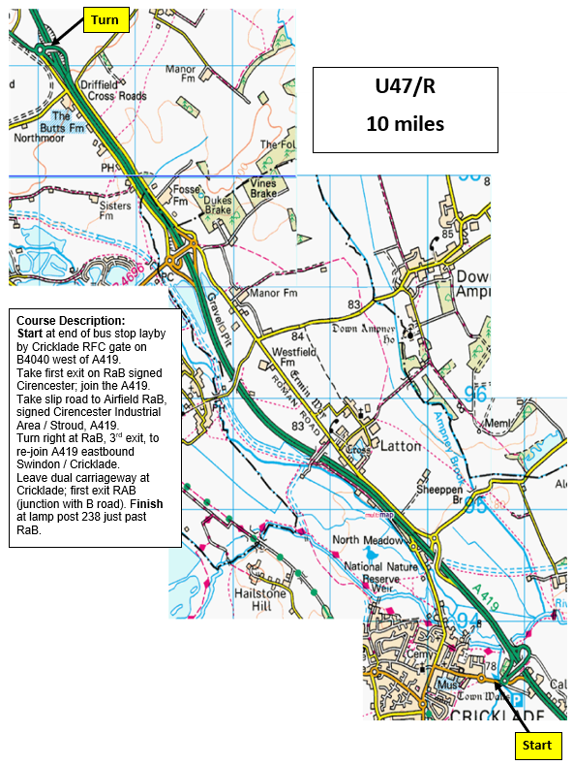

HQ
Cricklade Town Hall
High Street, Cricklade, Swindon, SN6 6AE
Open from 06:30
There is parking at the Town Hall, at the Rugby Club adjacent to the start and on local roads, but please be considerate to Cricklade residents.
START: 800 metres from HQ
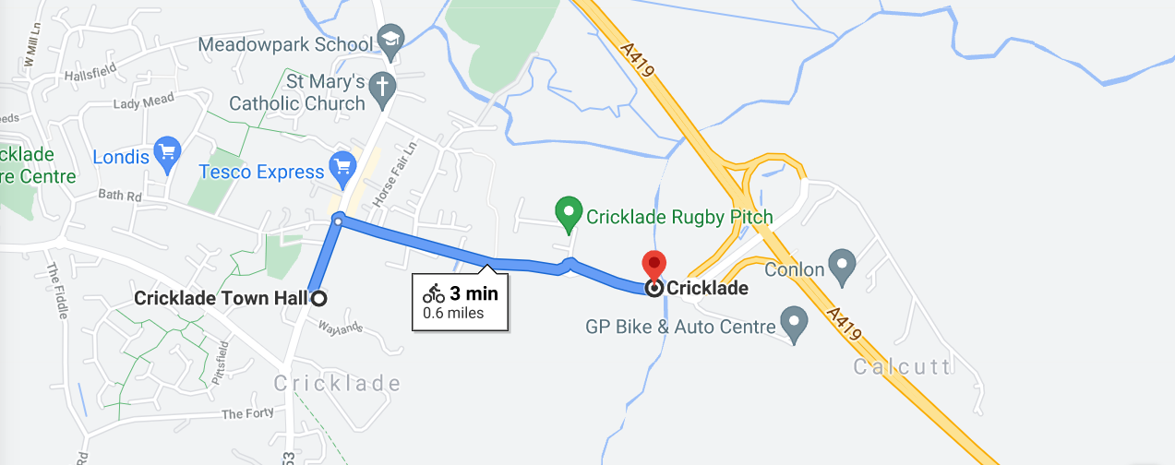
Health and Safety
Key points as follows:
- Do not attend if you feel ill in ANY way especially if you or family members have any symptoms of Covid-19.
- When collecting and returning race numbers and for any other use of the HQ, face masks must be worn at all times and 2m social distancing maintained.
- Please bring your own pen for signing on/out. If a queue forms for signing on/out and for collection / drop-off of numbers, competitors to queue individually at a 2m distance.
- People should NOT be socialising with others in the car park and should upon leaving their car, get their bike out and go straight out onto the road to warm up; a large collection of people has a negative perception and should be avoided.
- It is preferable for all warm-ups to be conducted independently and ideally competitors should warm up on the road individually. If a turbo trainer is to be used, it must be located away from the sign-on area, and at least 2 metres social distancing from all others to include those walking past e.g., any thoroughfare or common route.
- The Pusher-off will be wearing a face mask, but riders may choose not to accept a push off.
- Please respect the timekeepers and race officials, allow them space to practice social distancing, and do not attempt to leave with them any personal possessions for safe keeping.
- Normal rules apply when passing other competitors during the event, and for avoiding drafting.
- Competitors on finishing should not stop at the finish and should not loiter at the HQ/car park. Upon completion of their ride all competitors should sign out and return their number promptly.
- Race numbers will be sanitised before and after the event. After the event, race numbers to be returned to the HQ.
- When joining the A419, please use the full length of the slip road before moving onto the dual carriageway, to provide approaching vehicles the maximum opportunity to be aware of your presence.
- Take care at turn on roundabout – give way to traffic already on the roundabout.
- After completing the event, riders must not stop or congregate, but proceed back to the HQ.
- In the interests of your Own Safety, Cycling Time Trials and Tetbury Velos strongly advise competitors to wear a HARD-SHELL HELMET that meets an internationally accepted safety standard. Cycling Time Trial regulations require all competitors under the age of 18 years to wear a HARD-SHELL HELMET.
- Use of a working rear light, either flashing or constant, is required during the event.
- Head-down riding can cause life changing injuries both to yourself and other competitors. Please keep your head up and concentrate on the road ahead.
- Should the event need to be abandoned; this will be done in accordance with CTT guidelines.

